INFS 774 Big Data Analytics Quiz 2

Due 8/5/2020 (no grace period)

Your task:

Watch LinkedIn Learning (formerly Linda.com) course [Kafka Essential Training](https://www.linkedin.com/learning/kafka-essential-training/what-is-the-log?u=41911212) by Ben Sullins. In order to go to the course, you need to go through the following steps:

1. Go to https://library.dsu.edu/, scroll down, in the box “Featured Databases” find LinkedIn Learning (Lynda.com) and click it.
2. Click sign in in the upper right corner, and sign in with your university email address. Then you will see the message “Your organization requires you to sign in with Single Sign-On”. Please use your DSU network credential to log in.
3. In the search box, type the course name “[Kafka Essential Training](https://www.linkedin.com/learning/kafka-essential-training/what-is-the-log?u=41911212)” and you can find the course.

Again, if you are unable to log onto the linkedlearning learning website, please email [Vaughan.Hennen@dsu.edu](mailto:Vaughan.Hennen@dsu.edu)and cc me ASAP.

**Things to submit:**

1. The course “[Kafka Essential Training](https://www.linkedin.com/learning/kafka-essential-training/what-is-the-log?u=41911212)” includes 6 chapters. For each chapter, you need to capture a screenshot that shows you have finished watching the chapter. An example of such a screenshot is below – you want to make sure all the checkmarks in front of the chapter contents are checked. You don’t need to do screenshots for “Introduction” and “Conclusion”

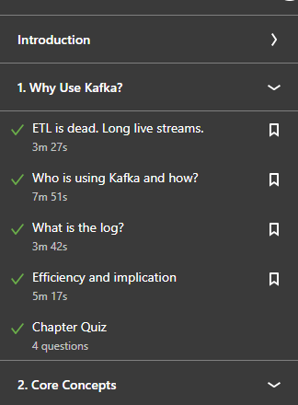

1. Among these chapters, four of them (chapter 1, 2, 3, and 5) have chapter quizzes. Please finish the quizzes (you are allowed to “try again” if your answer to a question is incorrect) and do screenshots of each quiz when you finish it. An example of such screenshot is below.

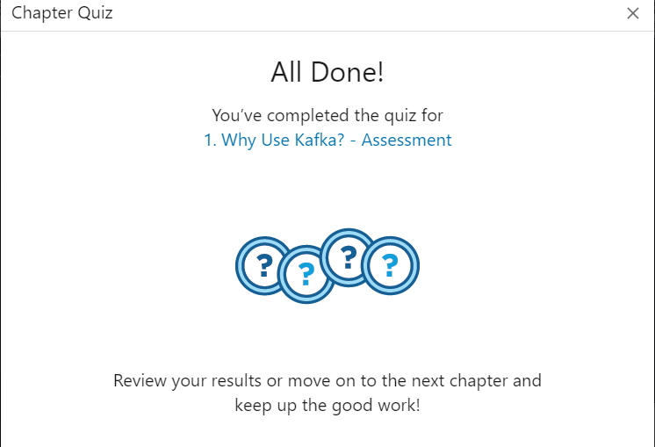

1. Copy and paste these screenshots (should be 6 for the chapter contents and 4 for the quizzes) in a word document and submit the word document by 8/5 (with no grace period) to the dropbox “Quiz 2” under Assessment-> Dropbox on D2L.